What is a Scapular?
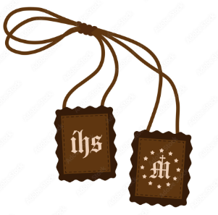
The Brown Scapular is one of many sacramentals of the Catholic Church. What is its origin? Why should Catholics wear one? What other types of scapulars are there?
Come learn more about this beautiful Marian devotion.
Each participant will receive a blessed scapular!
Wednesday, May 15th from 6:45 - 8:45 p.m.
in the coffee hour room (enter hall from Ford Street lot)
St. John the Baptist Catholic Church
502 Ford St., Bridgeport, PA
Parking available in the Ford Street lot, adjacent to the rectory & hall.
(No Commitment – Meetings are Monthly – Come When You Can!)
The Society of Patricians is sponsored by the Legion of Mary.
More info: r.edel.lukens@gmail.com or 610-256-7125
The society of the Patricians is an informal group of adult Catholics who meet monthly under the direction of Fr. Sam Keyes to learn more about the Catholic Faith so that they can better share it with others.
Please come, and bring a friend!
Refreshments will be served and free literature will be available.

